2025 Bachelor’s Graduation Thesis

Development of a CAM System for Incremental Forming of CFRTP from 3D CAD Data
Precision Engineering Research Group
Green Engineering and Applied Sciences Course
Faculty of Science and Technology
Sophia University
A2177802
Karter Wong

Guidance Professor Hidetake Tanaka
Submitted on 17 July 2022

Table of Contents
Chapter 1: Introduction 5
1.1 Background information: Incremental Forming 5
1.1.1 Development History 5
1.1.2 Types of Incremental Forming 5
Primary Types of Incremental Forming 6
- Single Point Incremental Forming (SPIF): 6
- Two Point Incremental Forming (TPIF): 7
- Double Sided Incremental Forming (DSIF): 7
1.1.3 Applications of Incremental Forming 8
1.2 NC Machine Tools 12
1.2.1 Overview 12
1.2.2 G-Code and Functions 12
1.2.3 3D CAD 13
1.2.4 CAM 13
1.2.5 Python 14
1.2.6 Tool path 14
1.3 CFRP (Carbon Fiber Reinforced Plastic) 15
1.3.1 Overview 15
1.3.2 Classification and characteristics of CFRP 15
Thermosetting vs. Thermoplastic CFRP 15
Continuous vs. Discontinuous Fiber CFRP 15
1.3.3 CFRP Application Areas 16
1.3.4 CFRP Sample Used in This Study 16
1.4 Previous Research A 16
1.4.1 Overview 16
1.4.2 CAM and CAD System 16
1.4.3 Experimental Equipment 17
1.4.4 Results 18
1.4.5 Conclusions 18
1.5 Current Research Objectives 19
Chapter 2: Toolpath Generation 20
2.1 Program Overview 20
2.2 Libraries and Variables 21
libraries 21
Variables 21
2.3 Modules 22
Loading STL File and Extracting Point Cloud 22
Filtering Close Points to Prevent Clustering 23
Sorting Points to Prevent Doubling Back 24
Smoothing Hull Points 26
Applying Reverse Offset 27
2.4 Toolpath Generation Process 29
Main Toolpath Generation Loop 29
2.6 G-Code Generation and Export 33
2.7 NC Viewer Confirmation 35
Chapter 3: Experimental Equipment 37
3.1 Machining Center 37
3.2 Python 38
3.3 Discontinuous CFRTP 38
3.4 Oil Bath 39
3.5 Type of Oil 39
3.6 Forming tool 40
3.7 Master mold 40
3.9 Jig Dimensions 40
Chapter 4: Incremental Forming Experiment 43
4.1 Experimental Setup 43
4.2 Procedure 43
4.3 Results 45
Chapter 5: Conclusion and Future Improvements 46
Appendix 47
Chapter 6: References 59

Chapter 1: Introduction

1.1 Background information: Incremental Forming
The demand for lightweight, durable, and sustainable materials in modern manufacturing has spotlighted Carbon Fiber Reinforced Plastics (CFRP) due to their high strength-to-weight ratio and excellent mechanical properties [1]. Traditional molding techniques, while efficient for high-volume production, incur significant costs for low-volume, complex CFRP components due to the need for custom molds [2]. This increases manufacturing and consumer costs, limiting accessibility. Dieless forming methods, such as 3D printing and incremental forming, offer a cost-effective solution for low-volume production by eliminating the need for molds, enabling flexible and economical manufacturing of complex shapes [2]. The exceptional properties of CFRP necessitate innovative techniques, such as incremental forming, to address the challenges of low-volume, high-mix production.

1.1.1 Development History
Incremental forming, pioneered in Japan during the 1990s by researchers such as Matsubara [10], is a dieless manufacturing technique designed for low-volume, complex components. Unlike traditional molding, it deforms materials through localized, incremental tool movements, offering flexibility for prototyping and custom production [2]. The method encompasses techniques like hot forming and local heating, primarily for metals and composites. Its key characteristics include:
- High geometric flexibility for complex shapes
- Elimination of dedicated molds
- Suitability for thin-shell structures
- Enhanced forming limits for sheet materials
- Cost-effective production for low-demand components

1.1.2 Types of Incremental Forming
There are many types of incremental forming, however most types of incremental forming are categorized into three main categories; Single Point Incremental Forming (SPIF), Two Point Incremental Forming (TPIF), and Double-Sided Incremental Forming (DSIF). For this research paper, single point incremental forming was used and therefore two point and double-sided incremental forming will not be explained in following sections as they are not relevant to the research paper.

Single Point Incremental Forming (SPIF):
Single point incremental forming is the simplest and most economical variant, where a tool deforms the sheet incrementally without the need of mold. The work piece or sheet of material often is supported by a backing plate. The process is highly flexible, allowing for rapid prototyping and low-volume production, as it can be executed on conventional CNC machines without the need for hydraulic presses. SPIF is ideal for creating parts directly from CAD models, eliminating the need for male or female dies. However, it may suffer from reduced accuracy due to springback and longer forming times. Applications include prototyping and small-batch production, with studies highlighting its increased formability but lower final accuracy.
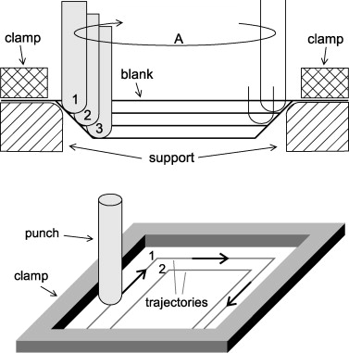
Figure 1: Principle of Single Point Incremental forming, originally realized by Iseki et al. (1989).

1.1.3 Applications of Incremental Forming
Incremental forming’s inherent flexibility and cost-effectiveness make it a pivotal technique for low-volume, high-mix manufacturing, particularly in prototyping, custom component production, and material testing [2]. By eliminating the need for dedicated molds, incremental forming reduces setup costs and lead times, enabling rapid production and customization across various industries. Its ability to produce complex geometries with high forming limits enables Incremental forming as a solution for applications requiring lightweight, durable components, especially when using advanced materials like Carbon Fiber Reinforced Thermoplastics (CFRTP) [12].

Automotive Industry
In the automotive sector, incremental forming is increasingly adopted for low-volume production of complex, lightweight components, aligning with the industry’s shift toward sustainable and efficient manufacturing [11]. For example, Toyota Motor Corporation utilizes static incremental forming to fabricate the front bumper of the Lexus LC Edge, achieving precise shaping without molds, which reduces production costs by approximately 30% compared to traditional molding for low-volume runs [6]. The bumper, constructed from discontinuous CFRTP (PA6 matrix, 20wt% carbon fiber), leverages the material’s isotropic strength and high press formability to achieve a surface roughness of Ra < 2 µm and dimensional accuracy of ±0.1 mm [5]. Similarly, Ford employs incremental forming for custom interior panels in the Mustang Mach-E electric vehicle, enabling rapid prototyping of lightweight dashboard components with complex curvatures, reducing component weight by 15% compared to aluminum alternatives [11, 13]. Nissan applies the technique for structural components in the Leaf electric vehicle, such as battery enclosure supports, which benefit from CFRTP’s vibration absorption and corrosion resistance, enhancing vehicle range by 5% through weight reduction [11, 14]. These applications demonstrate the incremental forming process’s ability to meet stringent automotive requirements for weight, strength, and cost efficiency.


Figure 2.2: Incremental Forming Application in Lexus LC Edge Front Bumper [Toyota Motor Corporation, 2020].

Aerospace Industry
In aerospace, incremental forming facilitates rapid prototyping and production of lightweight CFRP panels, critical for improving fuel efficiency and reducing emissions [1]. The Airbus A350, which incorporates 53% CFRP by weight, utilizes incremental forming to prototype fuselage panels with complex curvatures, achieving a weight reduction of 20% compared to aluminum counterparts [12, 15]. The process allows for iterative design adjustments without costly mold revisions, reducing development time by up to 40% [15]. Similarly, Boeing employs incremental forming for winglet components in the 787 Dreamliner, leveraging the technique’s high geometric flexibility to produce thin-shell structures with tensile strengths exceeding 1.5 GPa [1, 16]. The ability to form discontinuous CFRTP panels with minimal springback (< 5%) enhances dimensional accuracy, critical for meeting aerospace tolerances of ±0.05 mm [5]. Incremental forming also supports material testing, enabling engineers to evaluate CFRP’s fatigue resistance under simulated flight conditions, ensuring compliance with International Civil Aviation Organization (ICAO) standards [17].

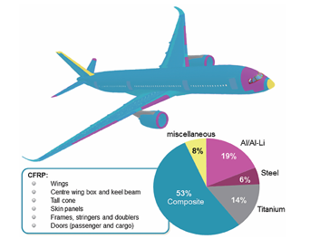
Figure 1.4: Materials used in modern aircraft, the airbus A350 XWB [, 2025].

Medical Applications
In the medical field, incremental forming supports the production of lightweight, high-strength components tailored to patient-specific needs [4]. A key application is the fabrication of prosthetic sockets, where discontinuous CFRTP’s isotropic strength and low weight (1.8 g/cm³) reduce wearer fatigue by 10–15% compared to traditional materials like acrylic resins [4, 18]. The process enables rapid customization of socket geometries, achieving dimensional accuracies of ±0.2 mm to ensure a precise fit [18]. Additionally, incremental forming is used to produce radiolucent head braces for brain surgery, leveraging CFRTP’s transparency to X-rays to enable clear imaging while maintaining structural rigidity (tensile strength ~1.5 GPa) [4, 19]. These braces, formed at temperatures of 180–200°C, exhibit smooth surfaces (Ra < 1.5 µm) and minimal defects, critical for patient safety [5]. The technique’s flexibility also supports prototyping of orthopedic implants, such as bone plates, where CFRTP’s corrosion resistance extends implant longevity [19].

Figure 1.5: CFRTP Prosthetic Socket Formed via Incremental Forming
Custom prosthetic socket demonstrating lightweight construction and precise fit for enhanced patient comfort [Author, 2025].

Emerging Applications
Beyond traditional sectors, incremental forming is gaining traction in emerging fields such as renewable energy and consumer electronics. In wind energy, the technique is used to prototype CFRTP turbine blade tips, optimizing aerodynamic profiles with weight reductions of 25% compared to fiberglass, enhancing energy efficiency [20]. In consumer electronics, incremental forming enables the production of lightweight CFRTP casings for portable devices, such as laptop chassis, offering superior strength-to-weight ratios (specific strength ~10 times that of steel) and aesthetic finishes [21]. These applications highlight incremental forming’s versatility in addressing diverse manufacturing challenges, particularly for sustainable, low-volume production.

Table 1.1: Applications of Incremental Forming Across Industries
Industry | Application | Material | Benefits | Reference
Automotive | Lexus LC Edge Bumper | Discontinuous CFRTP | 30% cost reduction, Ra < 2 µm | [6]
Automotive | Mustang Mach-E Interior Panels | Discontinuous CFRTP | 15% weight reduction | [13]
Automotive | Leaf Battery Enclosure | Discontinuous CFRTP | 5% range increase | [14]
Aerospace | A350 Fuselage Panels | Continuous CFRP | 20% weight reduction, ±0.05 mm accuracy | [15]
Aerospace | 787 Winglet Components | Continuous CFRP | High strength (>1.5 GPa) | [16]
Medical | Prosthetic Sockets | Discontinuous CFRTP | 10–15% fatigue reduction, ±0.2 mm accuracy | [18]
Medical | Radiolucent Head Braces | Discontinuous CFRTP | X-ray transparency, Ra < 1.5 µm | [19]
Renewable Energy | Turbine Blade Tips | Discontinuous CFRTP | 25% weight reduction | [20]
Consumer Electronics | Laptop Chassis | Discontinuous CFRTP | High specific strength | [21]

The broad applicability of incremental forming underscores its potential to transform manufacturing paradigms, particularly for CFRTP components. By enabling cost-effective production of complex, lightweight parts, the technique supports sustainability goals across industries, aligning with global trends toward reduced emissions and resource efficiency [17].

1.2 NC Machine Tools

1.2.1 Overview
Numerical Control (NC) machines execute automated operations via programmed numerical commands, controlling tool position, speed, and operations with high precision [9]. Unlike manual processes, NC automation reduces processing times, enhances productivity, and lowers labor costs. Computer Numerical Control (CNC), an advanced form of NC, leverages computer-based systems for greater flexibility and accuracy, making it prevalent in modern manufacturing [9].

1.2.2 G-Code and Functions
An NC program automates CNC machine operations through blocks of code, such as:
G01 X8 Y10 Z9;

Each block comprises a function section (e.g., G01 for linear interpolation) and a coordinate section (e.g., X8 Y10 Z9 for tool position). G-codes serve as preparatory functions, M-codes handle auxiliary operations (e.g., spindle start/stop), F-codes set feed rates, and S-codes control spindle speed [9]. Table 2.1 lists the G-codes used in this research.
Table 2.1: G-Code Functions for Incremental Forming
G Code | Positioning |  | G00
G Code | Linear interpolation |  | G01
G Code | Circular interpolation | Clockwise | G02
G Code | Helical interpolation | Counter clockwise | G03
G Code | Plane Selection | XY Plane | G17
G Code | Plane Selection | YZ Plane | G18
G Code | Plane Selection | ZX Plane | G19
G Code | Inch input |  | G20
G Code | mm input |  | G21
G Code | Local coordinate system settings |  | G52
G Code | Machine coordinate system selection |  | G53
G Code | Work coordinate system selection |  | G54-G59
G Code | Absolute coordinate command |  | G90
G Code | Relative coordinate command |  | G91
G Code | Work coordinate system settings. |  | G92
M Code | Spindle section |  | M03
M Code | Program end |  | M30
F Code | Feed Speed (mm/min) |  | F5
S Code | Rotation Speed (RPM) |  | S5

1.2.3 3D CAD
Computer-Aided Design (CAD) software enables precise digital design of components [7]. Unlike 2D CAD, 3D CAD, such as Creo Parametric 4.0 used in this study, supports complex geometries and prototyping, reducing production errors by enabling accurate STL file generation for toolpath creation [7]. All test pieces and molds in this research were designed using 3D CAD to ensure precision in incremental forming.
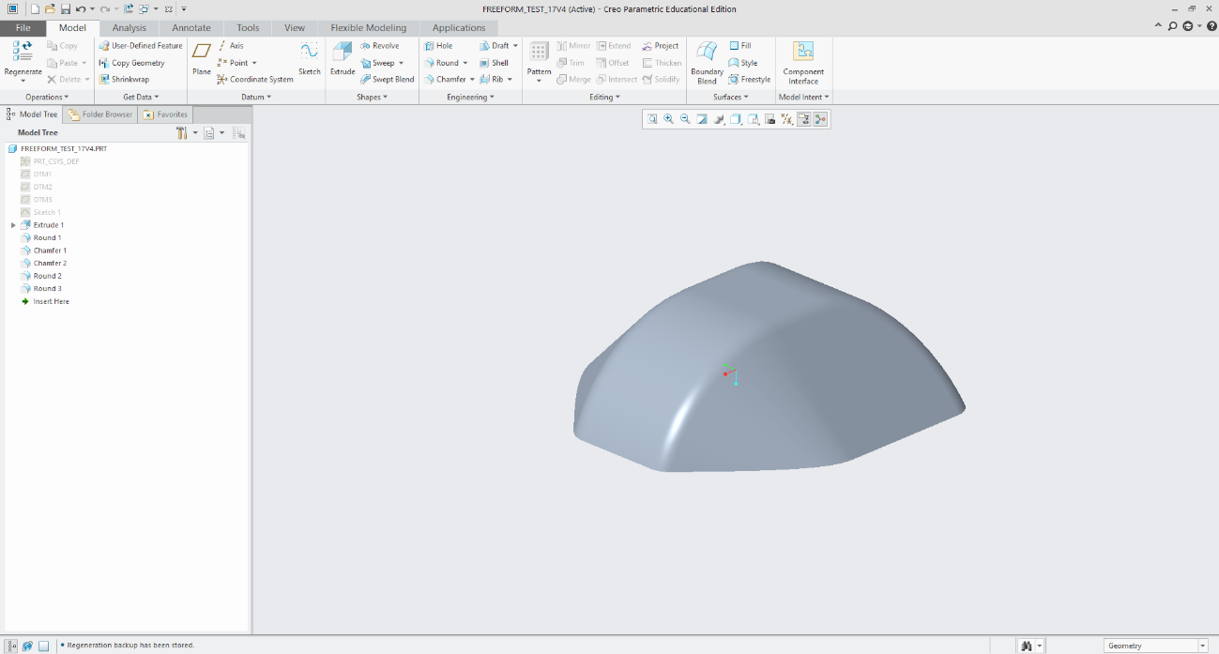
Figure 2.3: 3D CAD Model of Test Piece Designed in Creo Parametric [Author, 2025].

1.2.4 CAM
Computer-Aided Manufacturing (CAM) generates machining programs for CNC machines, automating toolpath creation and reducing manual input errors [7]. By simulating toolpaths, CAM prevents collisions and optimizes machining efficiency, significantly lowering production time and costs [7]. In this study, the CAM system processes STL files from Creo Parametric to produce G-code for incremental forming.

G90 ; (Absolute positioning)
G21 ; (Set units to millimeters)
G92 X0.0 Y0.0 Z0 ; (Set workpiece origin)
F1000 ; (Set feed rate)
G01 X0.0 Y0.0 Z20 ; (Move to safe height)

Figure 2.4: Sample G-Code for Incremental Forming [Author, 2025].

1.2.5 Python
Python, an open-source programming language, is renowned for its simplicity and extensive library ecosystem, enabling efficient development of complex applications [3]. Libraries such as NumPy, Pandas, and PyVista facilitate mesh processing and data manipulation, making Python ideal for CAM system development. In this study, Python was selected for its readability and ability to process STL files and generate optimized G-code toolpaths for incremental forming.

1.2.6 Tool path
A tool path is the path along which a machining tool moves. A tool path is created using the 3D coordinates of an STL file from CAD software to collect all the points or point cloud from the triangles of the STL file. From this, you sort the points, delete the duplicate points, generate a set of coordinates, and then add the necessary pieces to turn the coordinates into the NC program. The NC program can instruct the tool on the machining path. The toolpath was viewed using an NC viewer web browser to identify potential issues before manufacturing.
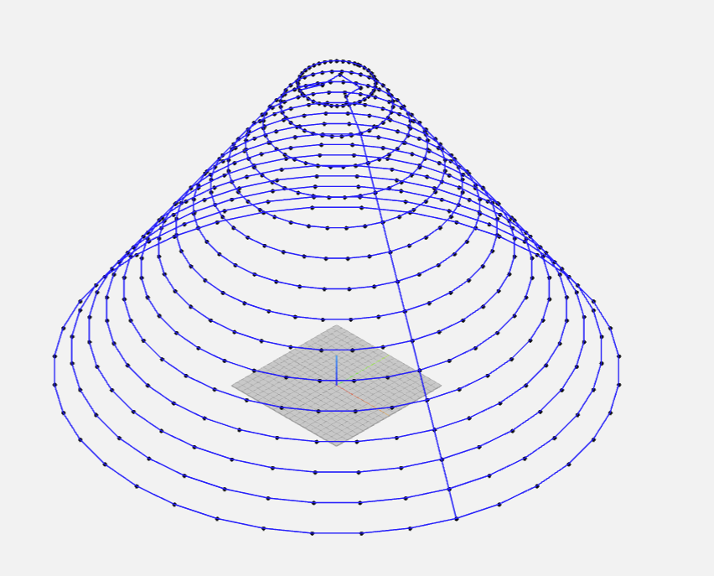
Figure 2.5: Toolpath Visualization for Truncated Cone [Author, 2025].

1.3 CFRP (Carbon Fiber Reinforced Plastic)

1.3.1 Overview
Carbon Fiber Reinforced Plastics (CFRP) combine carbon fibers with a polymer matrix to achieve superior mechanical properties, including a specific strength up to 10 times that of iron and a specific gravity of 1.8 g/cm³, significantly lower than aluminum (2.7 g/cm³) [12]. CFRP’s high strength-to-weight ratio, vibration absorption, and corrosion resistance make it ideal for applications in aerospace (e.g., aircraft wings), automotive (e.g., chassis components), sports equipment, and medical devices [1]. Its adoption has surged in industries prioritizing lightweight, durable materials [12].

1.3.2 Classification and characteristics of CFRP
CFRP is categorized by matrix type and fiber orientation, influencing its mechanical properties and applications [12].

Thermosetting vs. Thermoplastic CFRP
- CFRTS (Carbon Fiber Reinforced Thermosets): Characterized by high specific strength (e.g., 2.5 GPa tensile strength) and heat resistance (up to 200°C), CFRTS is used in aerospace and sports equipment but requires long molding times and is non-recyclable [12].
- CFRTP (Carbon Fiber Reinforced Thermoplastics): Offers lower specific strength (e.g., 1.5 GPa) and heat resistance but enables shorter molding times, lower costs, and partial recyclability, making it suitable for automotive applications [12].

Continuous vs. Discontinuous Fiber CFRP
- Continuous Fiber CFRTP: Features a layered structure with aligned fibers, providing high specific strength but limited formability due to anisotropic properties [12].
- Discontinuous Fiber CFRTP: Exhibits a random fiber orientation, offering isotropic strength and high press formability, ideal for complex shapes despite lower strength [12].
Figure 2.6: Schematic of Continuous and Discontinuous Fiber CFRP Orientations [Adapted from Tanata, 2023].

1.3.3 CFRP Application Areas
CFRP’s versatility supports applications across multiple industries due to its lightweight and high-strength properties [12]. In aerospace, CFRP is used for aircraft wings (e.g., Airbus A350, 53% CFRP by weight) to reduce fuel consumption [1]. In automotive, it enhances efficiency in components like bumpers and chassis (e.g., Lexus LC Edge) [6]. Medical applications include lightweight prosthetic sockets, reducing wearer fatigue, and radiolucent head braces for brain surgery, enabling clear X-ray imaging [4]. These applications leverage incremental forming’s flexibility for rapid prototyping and customization.

1.3.4 CFRP Sample Used in This Study
This study utilizes discontinuous fiber CFRTP (PA6 matrix, 20 wt% carbon fiber) due to its short molding time, cost-effectiveness, and partial recyclability, making it suitable for incremental forming of complex, low-volume components [12]. The random fiber orientation enhances press formability, aligning with the research’s focus on efficient toolpath generation.

1.4 Previous Research A

1.4.1 Overview
Previous research by Ikari and Tanaka [5] developed a Python-based CAM system for static incremental forming of discontinuous fiber CFRTP, utilizing an oil bath for material heating to enable dieless forming. The system generates G-code toolpaths from CAD models, addressing the high costs and inflexibility of traditional molding for low-volume, thin-shell components [5]. This study builds on their work by optimizing the CAM system for complex shapes, enhancing toolpath precision and surface quality.

1.4.2 CAM and CAD System
The CAM system achieved three goals: to read STL files from Creo Parametric 4.0, extract 3D point clouds of target shapes, and create a tool path in G-code. The code uses Python libraries, as seen in Figure X, to make a point cloud from the STL file. It converts the clouds into layers by Z-height and connects the points in each layer by the minimum Euclidean distance. Finally, it takes the coordinates and adds the proper syntax to be used by the CNC machines. The Shape created in Creo was a truncated cone with varying dimensions. The radius of the shape ranges from 20, 30, and 40 mm, and similarly, the wall angle is 30°, 40°, and 50°, and the pitch or resolution of the STL is 1. The dimensions were selected to match the working area and limitations of the experimental setup. The shape was chosen because it is good for proof of concept, especially for plastic deformation layering.

The CAM system developed by Ikari and Tanaka [5] achieved three objectives: reading STL files from Creo Parametric 4.0, extracting 3D point clouds, and generating G-code toolpaths. Using Python libraries (e.g., PyVista for mesh processing, Pandas for data handling, NumPy for numerical operations), the system processes STL files into layered point clouds sorted by Z-height, connecting points via minimum Euclidean distance to form toolpaths [3]. The test shape, a truncated cone (radii: 20, 30, 40 mm; wall angles: 30°, 40°, 50°; STL resolution: 1 mm), was selected to match the CNC machine’s workspace and demonstrate plastic deformation layering [5].

1.4.3 Experimental Equipment
The experimental setup from Ikari and Tanaka [5] is summarized in Table 2.2, with most equipment reused in this study for consistency.
Table 2.2: Experimental Equipment Specifications
Equipment | Description | Specification
CFRTP Sheet | PA6 matrix, 20 wt% carbon fiber | 110 mm × 110 mm × 1 mm, dried at 120°C for 24 h (ETTAS oven)
Oil Bath | T-22H (Thomas Scientific) | Up to 200°C, ±0.2°C precision, jet circulation
Silicone Oil | KF968 (Shin-Etsu) | Non-volatile, stable to 250°C, fire-resistant
CNC Machine | Sodick MC430L | X 420 mm, Y 350 mm, Z 200 mm, feed up to 36 m/min
Tool (Mandrel) | SUS304 | 5 mm diameter, 2.5 mm radius tip, 60 mm length
Jig | Custom design | Submerged in oil bath, secure clamping, detachable

1.4.4 Results
The experiments identified key parameters influencing successful incremental forming: material temperature, tool rotation, wall angle, and radius [5].
Temperature Effects
Optimal forming occurred at 180–200°C (453–473 K), achieving smooth surfaces and minimal defects. Below 160°C (433 K), insufficient softening led to cracks, with a minimum forming temperature of 50°C (323 K) [5].
Tool Rotation
A spindle speed of 1000 rpm enhanced forming depth (up to 14.9 mm) and surface smoothness (Ra < 2 µm), reducing uneven wall thickness compared to non-rotating conditions [5].
Wall Angle
Wall angles of 30° and 40° yielded smooth forming with minimal springback (< 5%). Angles near 40° showed minor deformations, while angles ≥ 50° risked cracking due to excessive stress [5].
Radius Variations
Smaller radii (20 mm) achieved deeper forming (14.9 mm) but increased wall stress (up to 300 MPa), while larger radii (40 mm) produced shallower forms (8 mm) with uniform wall strength [5].
Table 2.3: Forming Criteria Summary
Condition | Depth (mm) | Temperature (°C) | Radius (mm) | Wall Angle (°) | Spindle Speed (rpm)
Maximum | 14.9 | 200 | 20 | 40 | 1000
Minimum | 3.6 | 160 | 40 | 50 | 0

1.4.5 Conclusions
Ikari and Tanaka [5] developed a Python-based Computer-Aided Manufacturing (CAM) system that effectively generated G-code toolpaths from STL data, facilitating static incremental forming of discontinuous Carbon Fiber Reinforced Thermoplastic (CFRTP). By leveraging Python libraries such as PyVista, Pandas, and NumPy, their system extracted 3D point clouds, sorted them by Z-height, and connected points using a nearest-neighbor algorithm, enabling flexible production of complex shapes for low-volume applications [3, 5]. This approach, compatible with any CAD software producing STL files, supported industries like automotive and aerospace, as seen in applications like the Lexus LC Edge bumper [6]. However, limitations in handling intricate geometries and susceptibility to toolpath errors, such as point clustering and springback-induced distortions, particularly at wall angles ≥50°, highlighted the need for further refinement [5].

The current study, detailed in Chapter 4, enhances Ikari and Tanaka’s CAM system to improve precision and robustness for complex CFRTP shapes. Advanced algorithms, including a Traveling Salesperson (TSP) logic with O(n²) complexity, minimize tool travel and prevent path overlaps, while the Convex Hull module ensures accurate shape boundary definition [3, Chapter 4]. A reverse offset function adjusts for tool geometry (3.4 mm diameter) and springback (-0.1 mm Z-offset), and uniform layer spacing (0.2 mm) enhances toolpath smoothness [Chapter 4]. Validation via NC viewer software (e.g., NCPlot) ensures error-free G-code, optimizing forming under oil bath conditions (180–200°C), which achieves smooth surfaces (Ra < 2 µm) and deeper forming depths (up to 14.9 mm) [5, Chapter 4]. These improvements make the system suitable for high-precision, low-volume production.
Future enhancements, as outlined in Chapter 7, aim to address persistent challenges like springback and shape distortion through internal machining paths (scaling point clouds by 0.4 and 0.7) and advanced evaluation methods, such as scribed circle tests and 3D scanning with Einscan-SE [Chapter 7]. Exploring varied processing conditions, like pitch and feed speed, and testing more complex geometries beyond truncated cones will further expand the system’s applicability [Chapter 7]. By integrating these advancements, the CAM system offers a scalable, cost-effective solution for sustainable CFRTP manufacturing, with potential to transform prototyping and custom production in industries prioritizing lightweight, durable components [6, 12].

1.5 Current Research Objectives
This study aims to optimize a Python-based Computer-Aided Manufacturing (CAM) system to generate precise, error-free toolpaths for static incremental forming of discontinuous Carbon Fiber Reinforced Thermoplastic (CFRTP), addressing unresolved challenges in toolpath accuracy and material formability identified in prior work [5]. Building on Ikari and Tanaka’s research, which highlighted issues such as point clustering, path doubling, and springback-induced distortions in complex geometries, this research seeks to clarify the causes of these phenomena by analyzing the impact of toolpath generation algorithms on forming precision and surface quality [5]. Specifically, the study investigates how inefficiencies in point sorting and layer transitioning contribute to dimensional inaccuracies and uneven surface finishes, particularly at higher wall angles (≥50°), and aims to resolve these through advanced algorithmic enhancements. The specific purpose is to develop a robust CAM system that integrates the ConvexHull Python library and Traveling Salesperson (TSP) logic to streamline toolpath generation, ensuring smooth, optimized paths that minimize errors and enhance formability for intricate CFRTP shapes.
By validating the system’s performance using a Sodick MC430L CNC machining center under controlled oil bath conditions (180–200°C), the research will quantify improvements in toolpath efficiency and surface roughness (targeting Ra < 2 µm) while addressing springback through a reverse offset mechanism (-0.1 mm Z-offset) [5, Chapter 4]. This work enables cost-effective, low-volume production of high-quality CFRTP components, with applications in automotive and aerospace prototyping, such as lightweight structural parts [6, 12]. By defining optimal processing parameters and evaluating shape compliance via 3D scanning (e.g., Einscan-SE), the study clarifies the interplay between toolpath design, material behavior, and forming outcomes, providing a scalable solution for sustainable composite manufacturing [Chapter 7].

Chapter 2: Toolpath Generation

2.1 Program Overview
This chapter details an enhanced Python-based CAM system for generating toolpaths for static incremental forming of CFRTP, building on Ikari and Tanaka [5] to support complex geometries. The system processes STL data from Creo Parametric, generates optimized toolpaths, and converts them to G-code for CNC machining. The workflow includes: (1) STL data import, (2) variable and logic setup, (3) toolpath generation, (4) G-code conversion, and (5) validation. The entirety of the CAM system can be found in the Code A1 section of the appendix.
The Python-based CAM system code systematically transforms STL data into optimized G-code toolpaths for static incremental forming of CFRTP. Each component—library imports, STL processing, point filtering, sorting, smoothing, offsetting, toolpath generation, and G-code export—addresses specific challenges in achieving precise, error-free toolpaths for complex shapes. By incorporating advanced algorithms (e.g., ConvexHull, TSP-inspired sorting) and compensating for material and tool properties, the system enhances manufacturing efficiency and surface quality, supporting the research’s objective of advancing dieless forming for sustainable, lightweight composite production [5]. Future improvements could focus on integrating adaptive layer spacing and real-time error correction to further enhance robustness, as discussed in the referenced thesis [12].

Figure 4.1: CAM System Workflow for Toolpath Generation [Author, 2025].

2.2 Libraries and Variables

libraries
- Pandas: Utilized for data manipulation and storage, pandas provides the `DataFrame` structure to handle point cloud data extracted from STL files. Its ability to manage large datasets efficiently is crucial for processing the thousands of points typically generated from 3D models [3].
- NumPy: Provides high-performance numerical operations, including array manipulations and linear algebra functions (e.g., `np.linalg.norm` for distance calculations). NumPy’s efficiency is vital for handling the computational demands of toolpath generation [3].
- SciPy (ConvexHull): The `ConvexHull` module from SciPy computes the convex hull of 2D point sets, identifying the outermost points of each layer to define the toolpath boundary [3]. This ensures that only the external contour of the shape is machined, reducing unnecessary tool movements.
- STL (numpy-stl): The `mesh` module from the `numpy-stl` library reads STL files, extracting vertex coordinates to form the point cloud used for toolpath generation [7]. STL files are standard in CAD systems for representing 3D geometries as triangular meshes.

Variables
The parameters define the operational constraints and precision of the toolpath:
- TOOL_DIAMETER (2.5 mm): Specifies the diameter of the forming tool (a 5 mm SUS304 mandrel with a 2.5 mm radius tip). This parameter is used to calculate offsets, ensuring the tool’s geometry is accounted for during forming [5].
- Z_SPRINGBACK_OFFSET (-0.9 mm): Compensates for material springback, a phenomenon where CFRTP rebounds slightly after deformation due to its elastic properties [12]. A negative offset adjusts the Z-coordinate to press deeper, ensuring shape fidelity.
- LAYER_THICKNESS (1.0 mm): Defines the vertical increment between layers, controlling the resolution of the toolpath along the Z-axis. Uniform layer spacing ensures consistent forming depth [5].
- MIN_DISTANCE (0.5 mm): Sets the minimum distance between consecutive points in the toolpath to prevent clustering, which could cause tool vibration or surface imperfections [3].
- Z_OFFSET (50.5 mm): Adjusts the Z-coordinate of the entire toolpath to align with the CNC machine’s workspace, ensuring the tool operates within the safe working area [9].
- SAFE_Z_RELATIVE (50.0 mm): Specifies the height to which the tool retracts after forming, preventing collisions during tool withdrawal [9].

The libraries provide robust tools for data processing, while the configurable parameters allow customization to specific material properties (e.g., CFRTP’s springback) and machine constraints (e.g., Sodick MC430L’s workspace). This modular setup enhances the system’s adaptability to different shapes and materials, aligning with the research’s goal of flexible, low-volume production [2].

2.3 Modules

Loading STL File and Extracting Point Cloud
def load_stl_to_dataframe(stl_file, layer_thickness=1.0):
stl_mesh = mesh.Mesh.from_file(stl_file)
vertices = stl_mesh.vectors.reshape(-1, 3)
df = pd.DataFrame(vertices, columns=['x', 'y', 'z'])
df = df.drop_duplicates().reset_index(drop=True)
df['z'] = np.round(df['z'] / layer_thickness) * layer_thickness
return df.dropna()
Functionality
This function reads an STL file (e.g., `freeform_test_17v4.stl`) and converts its geometric data into a structured point cloud for toolpath generation. The process involves:
1. Reading the STL File: The `mesh.Mesh.from_file` function loads the STL file, which represents the 3D model as a collection of triangular facets. Each facet is defined by three vertices, each with x, y, z coordinates [7].
2. Reshaping Vertices: The `vectors` attribute of the STL mesh is a 3D array of shape `(n_triangles, 3, 3)`, where each triangle has three vertices with three coordinates. `reshape(-1, 3)` flattens this into a 2D array of shape `(n_vertices, 3)`, consolidating all vertex coordinates.
3. Creating a DataFrame: The vertices are stored in a pandas DataFrame with columns labeled `x`, `y`, `z`, facilitating structured data manipulation.
4. Removing Duplicates: `drop_duplicates()` eliminates redundant vertices, reducing computational overhead and ensuring unique points in the toolpath.
5. Z-Axis Rounding: The Z-coordinates are rounded to the nearest multiple of `layer_thickness` (1.0 mm) to enforce uniform layer spacing, critical for consistent incremental forming [5].
6. Dropping NaN Values: `dropna()` removes any incomplete data entries, ensuring data integrity.

Significance
The function transforms the raw geometric data of the STL file into a clean, organized point cloud suitable for further processing. By enforcing uniform Z-levels, it aligns with the layered approach of incremental forming, where the tool moves sequentially through Z-slices to shape the material [2]. The removal of duplicates and NaN values enhances computational efficiency and toolpath accuracy, addressing challenges in processing complex geometries [5].

---

Filtering Close Points to Prevent Clustering

Function: `filter_close_points`
def filter_close_points(points, min_distance=0.5):
filtered = [points[0]]
for p in points[1:]:
if np.linalg.norm(p - filtered[-1]) >= min_distance:
filtered.append(p)
return np.array(filtered)

Functionality
This function reduces point density in the point cloud to prevent clustering, which could lead to inefficient toolpaths or machining errors (e.g., tool vibration or surface gouging). The process includes:
1. Initialization: The first point is added to the `filtered` list to start the sequence.
2. Distance Check: For each subsequent point, the Euclidean distance (`np.linalg.norm`) to the last filtered point is calculated. If the distance exceeds `min_distance` (0.5 mm), the point is added to the filtered list.
3. Output: The filtered points are returned as a NumPy array, preserving only points sufficiently spaced apart.

Significance
Point clustering can occur in STL files with high mesh resolution, where multiple vertices are closely spaced, leading to redundant tool movements. By enforcing a minimum distance, this function optimizes the toolpath, reducing machining time and improving surface quality, particularly for CFRTP, which requires precise tool control to avoid defects [12]. This aligns with the research’s focus on efficient, error-free toolpaths for complex shapes [5].

Sorting Points to Prevent Doubling Back
Function: `sort_points_no_overlap`
```python
def sort_points_no_overlap(points):
center = points.mean(axis=0)
angles = np.arctan2(points[:, 1] - center[1], points[:, 0] - center[0])
sorted_indices = np.argsort(angles)
sorted_points = points[sorted_indices]
n = len(sorted_points)
for i in range(n):
p1, p2 = sorted_points[i], sorted_points[(i + 1) % n]
for j in range(i + 2, n):
p3, p4 = sorted_points[j], sorted_points[(j + 1) % n]
if intersects(p1, p2, p3, p4):
sorted_points[i + 1:j + 1] = sorted_points[i + 1:j + 1][::-1]
return sorted_points
```

Functionality
This function sorts points in a layer to create a non-overlapping, clockwise toolpath, minimizing travel distance and preventing toolpath intersections. The process involves:
1. Centroid Calculation: The mean of the points (`points.mean(axis=0)`) determines the layer’s centroid, serving as a reference for angular sorting.
2. Angular Sorting: The `np.arctan2` function computes the angle of each point relative to the centroid, and `np.argsort` orders points by these angles, ensuring a clockwise traversal.
3. Intersection Check: The function checks for intersections between line segments using the `intersects` helper function. If an intersection is detected (i.e., segments `p1-p2` and `p3-p4` cross), the points between `i+1` and `j+1` are reversed to eliminate the overlap.
4. Output: The sorted points are returned, forming a continuous, non-self-intersecting toolpath.

Helper Function: `intersects`
```python
def intersects(p1, p2, p3, p4):
def ccw(A, B, C):
return (C[1] - A[1]) * (B[0] - A[0]) > (B[1] - A[1]) * (C[0] - A[0])
return ccw(p1, p3, p4) != ccw(p2, p3, p4) and ccw(p1, p2, p3) != ccw(p1, p2, p4)
```
The `intersects` function uses the Counter-Clockwise (CCW) test to determine if two line segments intersect. The CCW test checks the orientation of point triplets; if the orientations differ across segments, an intersection exists.

Significance
The sorting algorithm, inspired by a simplified Traveling Salesperson Problem (TSP) approach, ensures an efficient, non-overlapping toolpath, critical for smooth CNC operation and high-quality surface finishes [3]. By preventing doubling back, it reduces machining time and mitigates risks of toolpath errors, aligning with the research’s goal of optimizing toolpath generation for complex CFRTP shapes [5].

---

Smoothing Hull Points

Function: `smooth_hull_points`
```python
def smooth_hull_points(points, alpha=0.3):
smoothed = points.copy()
for i in range(len(points)):
prev = points[(i - 1) % len(points)]
next = points[(i + 1) % len(points)]
smoothed[i] = (1 - alpha) * points[i] + alpha * (prev + next) / 2
return smoothed
```

Functionality
This function applies a smoothing algorithm to the convex hull points to reduce sharp transitions, improving toolpath continuity and surface quality. The process includes:
1. Initialization: A copy of the input points is created to preserve the original data.
2. Smoothing Calculation: For each point, a weighted average is computed using the current point (`points[i]`) and the average of its neighbors (`prev + next / 2`). The `alpha` parameter (0.3) controls the smoothing intensity, balancing the original point’s position (70%) with the neighbors’ influence (30%).
3. Circular Boundary Handling: The modulo operator (`% len(points)`) ensures continuity at the start and end of the point list, treating the path as a closed loop.
4. Output: The smoothed points are returned, reducing angularity in the toolpath.

Significance
Sharp transitions in the toolpath can cause abrupt tool movements, leading to surface imperfections or tool vibrations, particularly in CFRTP forming, where material properties demand smooth tool motion [12]. The smoothing algorithm enhances toolpath quality, ensuring uniform deformation and aligning with the research’s aim of achieving high surface quality in incremental forming [2].

Applying Reverse Offset

Function: `reverse_offset`
```python
def reverse_offset(points, TOOL_DIAMETER=2.5, z_springback_offset=-0.1):
adjusted_points = points.copy()
center = points[:, :2].mean(axis=0)
distances = np.linalg.norm(points[:, :2] - center, axis=1)
layer_radius = distances.max() if distances.size > 0 else 1.0
print(f"Layer at Z={points[0, 2]:.2f}, points={len(points)}, radius={layer_radius:.2f} mm, TOOL_DIAMETER={TOOL_DIAMETER:.2f} mm")
for i, point in enumerate(adjusted_points):
direction = point[:2] - center
norm = np.linalg.norm(direction)
if norm > 1e-6:
direction /= norm
offset = TOOL_DIAMETER * direction
adjusted_points[i, :2] -= offset
print(f"Point {i}: Offset applied = {offset[0]:.2f}, {offset[1]:.2f}")
adjusted_points[i, 2] += z_springback_offset
adjusted_points[:, :2] = smooth_hull_points(adjusted_points[:, :2])
x_min, x_max = adjusted_points[:, 0].min(), adjusted_points[:, 0].max()
y_min, y_max = adjusted_points[:, 1].min(), adjusted_points[:, 1].max()
adj_distances = np.linalg.norm(adjusted_points[:, :2] - center, axis=1)
adj_layer_radius = adj_distances.max() if adj_distances.size > 0 else 1.0
print(f"Adjusted radius={adj_layer_radius:.2f} mm")
print(f"Bounding box: X=[{x_min:.2f}, {x_max:.2f}], Y=[{y_min:.2f}, {y_max:.2f}]")
return adjusted_points
```

Functionality
This function adjusts the toolpath to account for the tool’s geometry and material springback, ensuring accurate forming. The process includes:
1. Centroid and Radius Calculation: The centroid of the 2D points (`points[:, :2].mean(axis=0)`) and the maximum distance to any point (`layer_radius`) define the layer’s geometry.
2. Offset Application: For each point, the direction vector from the centroid is normalized, and an offset equal to `TOOL_DIAMETER` (2.5 mm) is applied inward to adjust for the tool’s radius, ensuring the tool’s center follows the desired contour [9].
3. Springback Compensation: The Z-coordinate is adjusted by `z_springback_offset` (-0.1 mm) to counteract CFRTP’s elastic rebound [12].
4. Smoothing: The `smooth_hull_points` function is applied to the adjusted 2D points to reduce sharp transitions.
5. Debugging Output: The function prints layer statistics (Z-level, number of points, radius, and bounding box) to aid in toolpath validation.
6. Output: The adjusted 3D points are returned, incorporating the offset and smoothing.

Significance
The reverse offset compensates for the tool’s finite size and material properties, critical for achieving dimensional accuracy in incremental forming [2]. The springback offset addresses CFRTP’s tendency to partially recover its shape post-forming, ensuring the final shape matches the CAD model [12]. The debugging output facilitates toolpath verification, aligning with the research’s emphasis on error-free toolpaths [5].

2.4 Toolpath Generation Process

Main Toolpath Generation Loop

Code Segment
```python
ll = []
prev_exit_point = None
z_levels = sorted(df['z'].unique(), reverse=True)
if len(z_levels) > 1:
z_diffs = [z_levels[i] - z_levels[i + 1] for i in range(len(z_levels) - 1)]
avg_spacing = np.mean(z_diffs)
print(f"Average layer spacing in input data: {avg_spacing:.3f} mm")
else:
avg_spacing = 1
print("Only one Z level in input data, using default spacing of 1 mm")
uniform_z_levels = []
start_z = z_levels[0]
for i in range(len(z_levels)):
new_z = start_z - i * avg_spacing
uniform_z_levels.append(new_z)
center_x, center_y = None, None
for layer_idx, current_layer_z in enumerate(z_levels):
current_layer = df[df['z'] == current_layer_z][['x', 'y', 'z']].values
if len(current_layer) >= 5:
center_x, center_y = current_layer[:, :2].mean(axis=0)
break
if center_x is None or center_y is None:
print("Warning: Could not compute center from any layer. Using (0, 0) as fallback.")
center_x, center_y = 0.0, 0.0
for layer_idx, current_layer_z in enumerate(z_levels):
current_layer = df[df['z'] == current_layer_z][['x', 'y', 'z']].values
if len(current_layer) < 5:
print(f"Skipping layer at Z={current_layer_z:.2f} due to insufficient points ({len(current_layer)})")
continue
layer_points_2d = current_layer[:, :2]
try:
hull = ConvexHull(layer_points_2d)
hull_coords = layer_points_2d[hull.vertices]
except Exception as e:
print(f"Skipping layer at Z={current_layer_z:.2f} due to hull error: {str(e)})")
continue
if hull_coords.shape[0] < 5:
print(f"Skipping layer at Z={current_layer_z:.6f} due to insufficient hull vertices ({hull_coords.shape[0]})")
continue
hull_coords = filter_close_points(hull_coords, min_distance=MIN_DISTANCE)
hull_z = np.full((hull_coords.shape[0], 1), uniform_z_levels[layer_idx])
hull_points_3d = np.hstack([hull_coords, hull_z])
adjusted_points_3d = reverse_offset(hull_points_3d, TOOL_DIAMETER=TOOL_DIAMETER, z_springback_offset=Z_SPRINGBACK_OFFSET)
adjusted_points_2d = adjusted_points_3d[:, :2]
sorted_points = sort_points_no_overlap(adjusted_points_2d)
if layer_idx == 0:
centroid = np.array([center_x, center_y])
dists = np.linalg.norm(sorted_points - centroid, axis=1)
start_idx = np.argmin(dists)
sorted_points = np.roll(sorted_points, -start_idx, axis=0)
elif prev_exit_point is not None:
dists = np.linalg.norm(sorted_points - prev_exit_point[:2], axis=1)
start_idx = np.argmin(dists)
sorted_points = np.roll(sorted_points, -start_idx, axis=0)
sorted_layer = np.hstack([sorted_points, np.full((sorted_points.shape[0], 1), adjusted_points_3d[0, 2])])
layer_path = list(sorted_layer)
layer_path.append(layer_path[0]) # Close the loop
ll.extend(layer_path)
prev_exit_point = layer_path[0]
if len(ll) == 0:
print("Warning: No toolpath points generated. Check input data or layer filtering.")
exit()
```

Functionality
This section orchestrates the toolpath generation process, processing each Z-level of the STL point cloud to create a continuous toolpath. The steps are:
1. Initialization: An empty list `ll` stores the toolpath points, and `prev_exit_point` tracks the last point of each layer for smooth transitions.
2. Z-Level Extraction: The unique Z-coordinates (`df['z'].unique()`) are sorted in descending order to process layers from top to bottom, mimicking the incremental forming process [2].
3. Uniform Layer Spacing: The average Z-spacing (`avg_spacing`) is calculated from the differences between Z-levels. New uniform Z-levels are assigned to ensure consistent layer increments, critical for CFRTP forming [5].
4. Centroid Calculation: The centroid of the first valid layer (with at least 5 points) is computed to initialize the toolpath start point. A fallback centroid (0, 0) is used if no valid layer is found.
5. Layer Processing:
- Point Filtering: Layers with fewer than 5 points are skipped to ensure sufficient data for convex hull computation.
- Convex Hull: The `ConvexHull` function identifies the outermost points of the 2D layer, defining the contour for machining [3].
- Point Filtering: `filter_close_points` removes closely spaced points to optimize the toolpath.
- Z-Assignment: Uniform Z-levels are assigned to the hull points to maintain consistent layer spacing.
- Offset and Smoothing: `reverse_offset` adjusts points for tool geometry and springback, followed by smoothing via `smooth_hull_points`.
- Point Sorting: `sort_points_no_overlap` orders points to prevent overlaps, ensuring a smooth, clockwise path.
- Layer Start Point: For the first layer, the point closest to the centroid is chosen as the start. For subsequent layers, the point closest to the previous layer’s exit point is selected to minimize travel distance.
- Loop Closure: The first point of each layer is appended to close the contour, ensuring a continuous path.
6. Toolpath Storage: The processed layer points are added to `ll`, and the exit point is updated for the next layer.
7. Error Handling: If no toolpath points are generated, the program exits with a warning, indicating issues with the input STL data.

Significance
The main loop integrates all previous functions to create a cohesive toolpath, addressing the research’s goal of supporting complex geometries [5]. The use of uniform Z-levels and convex hulls ensures compatibility with CNC machining, while the nearest-neighbor start point selection optimizes tool travel, reducing machining time and enhancing efficiency [3]. The robust error handling aligns with the research’s emphasis on error-free toolpaths [2].

Figure 4.2: Toolpath Generation for Complex Shape [Author, 2025].

2.6 G-Code Generation and Export
```
python
ll = np.array(ll)
ll[:, 2] -= Z_OFFSET
ll = np.round(ll, 2)
pd.DataFrame(ll, columns=['x', 'y', 'z']).to_csv('toolpath.csv', index=False)
df_ltp = pd.read_csv('toolpath.csv')
df_ltp['x'] = df_ltp['x'].round(2)
df_ltp['y'] = df_ltp['y'].round(2)
df_ltp['z'] = df_ltp['z'].round(2)
df_gchord = pd.DataFrame({
'G': 'G01',
'x': 'X' + df_ltp['x'].map('{:.2f}'.format),
'y': 'Y' + df_ltp['y'].map('{:.2f}'.format),
'z': 'Z' + df_ltp['z'].map('{:.2f}'.format),
'EOB': ';'
})
first_x = round(df_ltp.iloc[0]['x'], 2)
first_y = round(df_ltp.iloc[0]['y'], 2)
first_z = round(df_ltp.iloc[0]['z'], 2)
gcode_header = [
"G90 ; (Absolute positioning)",
"G21 ; (Set units to millimeters)",
"M03 ; (Start spindle)",
"S500 ; (Setting spindle speed)",
"F1000 ; (Set feedrate)",
f"G00 X{center_x:.2f} Y{center_y:.2f} ; (Rapid move to centroid)",
f"G01 Z{first_z:.2f} ; (Drop to first point's Z)",
f"G01 X{first_x:.2f} Y{first_y:.2f} ; (Move to first toolpath point)"
]
last_x = round(df_ltp.iloc[-1]['x'], 2)
last_y = round(df_ltp.iloc[-1]['y'], 2)
last_z = df_ltp.iloc[-1]['z']
final_safe_z = last_z + SAFE_Z_RELATIVE
gcode_footer = [
f"G01 X{last_x:.2f} Y{last_y:.2f} Z{final_safe_z:.2f} ; (Retract tool to safe Z)",
"M30 ; (End of program)"
]
with open('Gchord.txt', 'w') as f:
for line in gcode_header:
f.write(line + '\n')
df_gchord.to_csv(f, index=False, sep=" ", header=False, mode='a')
for line in gcode_footer:
f.write(line + '\n')
```

Functionality
This section converts the toolpath into G-code and exports it for CNC machining. The steps are:
1. Z-Offset Application: The Z-coordinates are adjusted by subtracting `Z_OFFSET` (50.5 mm) to align the toolpath with the CNC machine’s workspace.
2. Rounding: Coordinates are rounded to two decimal places for compatibility with CNC precision requirements [9].
3. Toolpath Storage: The toolpath is saved as a CSV file (`toolpath.csv`) for intermediate storage and validation.
4. G-Code Generation: A DataFrame (`df_gchord`) is created with G-code commands (`G01` for linear interpolation), prefixed coordinates (`X`, `Y`, `Z`), and semicolons (`;`) as end-of-block markers.
5. Header Creation: The G-code header initializes the CNC machine:
- `G90`: Sets absolute positioning.
- `G21`: Uses millimeters as units.
- `M03`: Starts the spindle.
- `S500`: Sets spindle speed to 500 rpm, optimized for CFRTP forming [5].
- `F1000`: Sets feed rate to 1000 mm/min.
- Rapid move (`G00`) to the centroid and linear moves (`G01`) to the first point’s Z and XY coordinates.
6. Footer Creation: The footer retracts the tool to a safe Z-height (`final_safe_z`) and ends the program (`M30`).
7. File Export: The header, toolpath, and footer are written to `Gchord.txt` for direct CNC input.

Significance
The G-code conversion ensures compatibility with the Sodick MC430L CNC machine, enabling automated incremental forming [9]. The header and footer streamline machine setup and shutdown, while the centroid-based initial move optimizes tool positioning, reducing setup time. This aligns with the research’s goal of efficient, low-volume production [2].

2.7 NC Viewer Confirmation
After the CAM system generates the toolpath, the NC viewer, an online website that visualizes the G-code, is used to ensure it is error-free. The NC viewer also simulates what will happen in the incremental forming process and can be edited as needed. Figure 4.4: NC viewer confirmation of the toolpath.
Revised:The generated G-code is validated using an NC viewer (e.g., NCPlot), which visualizes the toolpath to detect errors (e.g., collisions, discontinuities) and simulate the forming process. This ensures error-free execution on the CNC machine.
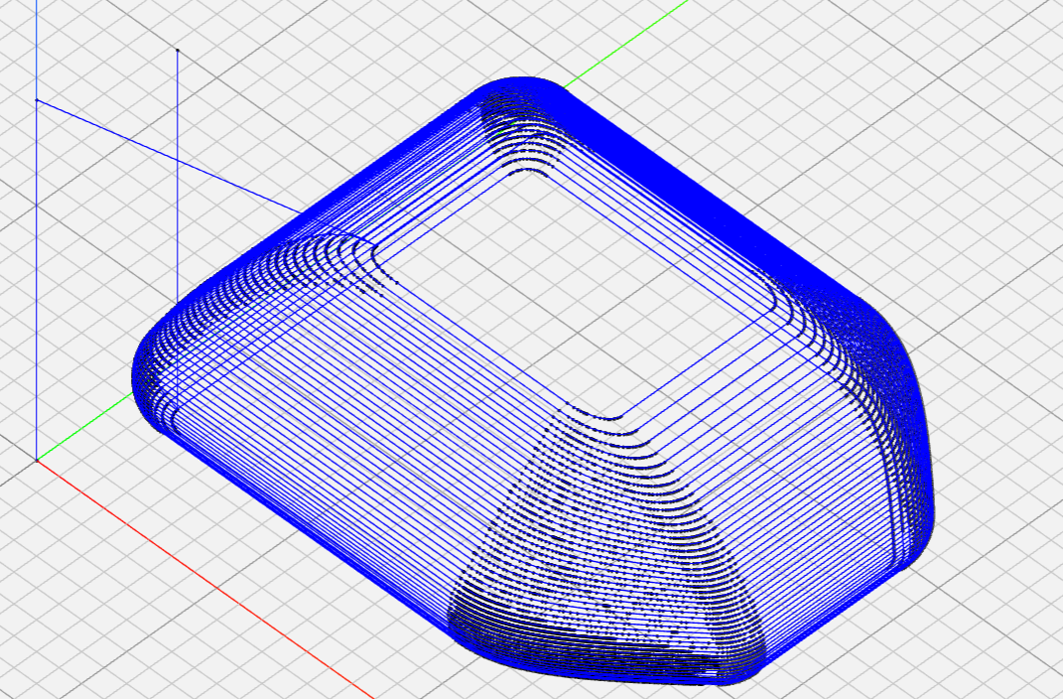
Figure 4.4. NC Toolpath Visulization [Author, 2025].

Chapter 3: Experimental Equipment
This chapter describes the experimental equipment used for static incremental forming of CFRTP. Much of the equipment used in this experiment will be the same as the equipment used in previous research A, located in the previous chapter on table 2.2. The following table will also include the
Table 3.1: Experimental Equipment Specifications
Equipment | Description | Specification
CFRTP Sheet | PA6 matrix, 20 wt% carbon fiber | 110 mm × 110 mm × 1 mm, dried at 120°C for 24 h (ETTAS oven)
Oil Bath | T-22H (Thomas Scientific) | Up to 200°C, ±0.2°C precision, jet circulation
Silicone Oil | KF968 (Shin-Etsu) | Non-volatile, stable to 250°C, fire-resistant
CNC Machine | Sodick MC430L | X 420 mm, Y 350 mm, Z 200 mm, feed up to 36 m/min
Tool (Mandrel) | SUS304 | 5 mm diameter, 2.5 mm radius tip, 60 mm length
Jig | Custom design | Submerged in oil bath, secure clamping, detachable

Figure 3.1: Experimental Setup Overview (a) Sodick MC430L, (b) T-22H Oil Bath, (c) Jig Arrangement [Author, 2025].

3.1 Machining Center
The Sodick MC430L, a precision linear nano machining center, was selected for its high accuracy (positioning accuracy: ±0.001 mm) and compatibility with G-code toolpaths used in incremental forming [9]. An incremental forming device and oil bath were integrated to enable dieless forming without specialized equipment.
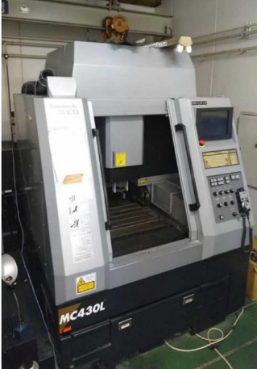
Figure 3.1: Appearance of M C430L [

3.2 Python
Python’s simplicity and libraries (e.g., NumPy, Pandas, PyVista) make it ideal for developing a CAM system to process STL data and generate G-code [3]. Its accessibility and computational efficiency support complex toolpath algorithms.

3.3 Discontinuous CFRTP
Discontinuous CFRTP (PA6 matrix, 20 wt% carbon fiber, 110 mm × 110 mm × 1 mm) was chosen for its isotropic strength, high press formability, and cost-effectiveness [12]. Sheets were dried at 120°C for 24 hours in a MOV-450S oven to prevent moisture-induced degradation.

3.4 Oil Bath
The T-22H oil bath (Thomas Scientific) provides uniform heating up to 200°C with ±0.2°C precision, ensuring consistent CFRTP softening during forming [5].
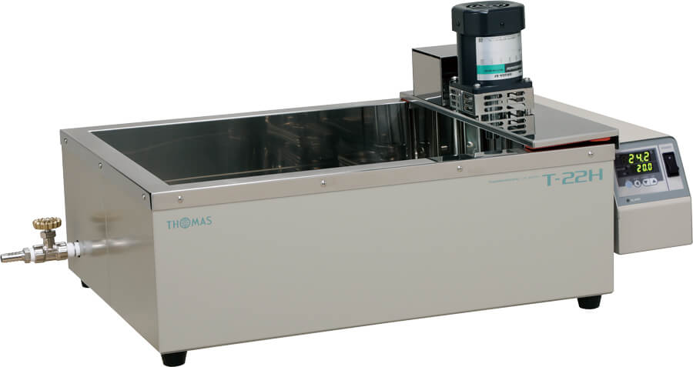
Figure 3.4: Appearance of T-22H [Author 2025]

3.5 Type of Oil
Shin-Etsu KF968 silicone oil was selected for its high temperature resistance (up to 250°C), low volatility, and fire resistance, ensuring safety and stability at 50–200°C (323–473 K) [5].


Figure 3.2: Shin-Etsu Chemical KF968 oil that is used. [Author, 2025]

3.6 Forming tool
A SUS304 mandrel (5 mm diameter, 2.5 mm radius tip, 60 mm length) was used, matching previous research for consistency and accommodating the machining center’s offset [5].
Mega Micro type S Chuck
Ød : | 0.45 - 6.05
ØD: | 14 mm
L: | 45
L1: | 32
G: | -
H1: | 28
H2: | 31

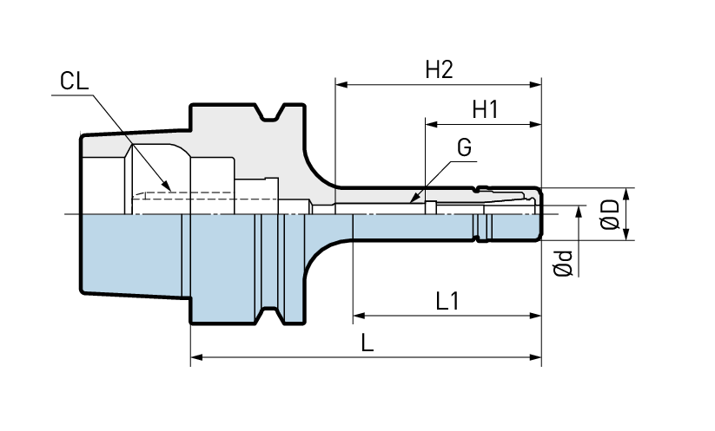
Figure x: Mega micro type s chuck without the tool

3.7 Master mold
A 3D-printed mold validated the feasibility of incremental forming, but its development is secondary to this study’s focus on toolpath generation.

3.9 Jig Dimensions
A custom jig with a removable upper frame secures CFRTP sheets during forming, enhancing safety and efficiency [5]. The jig can be used with and without the oil bath as shown in figures 3.7 and 3.8.
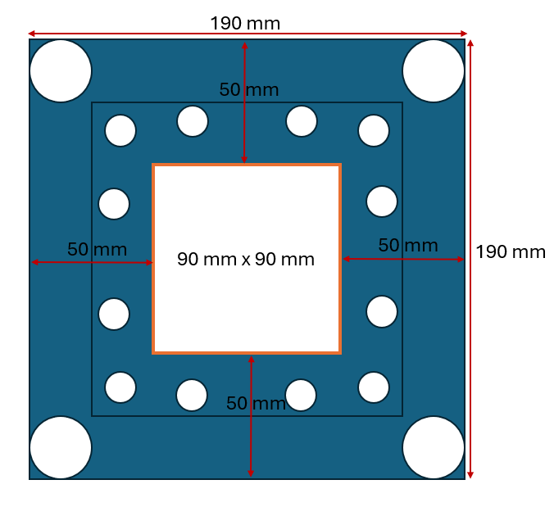
Figure 3.6: Jig dimensions
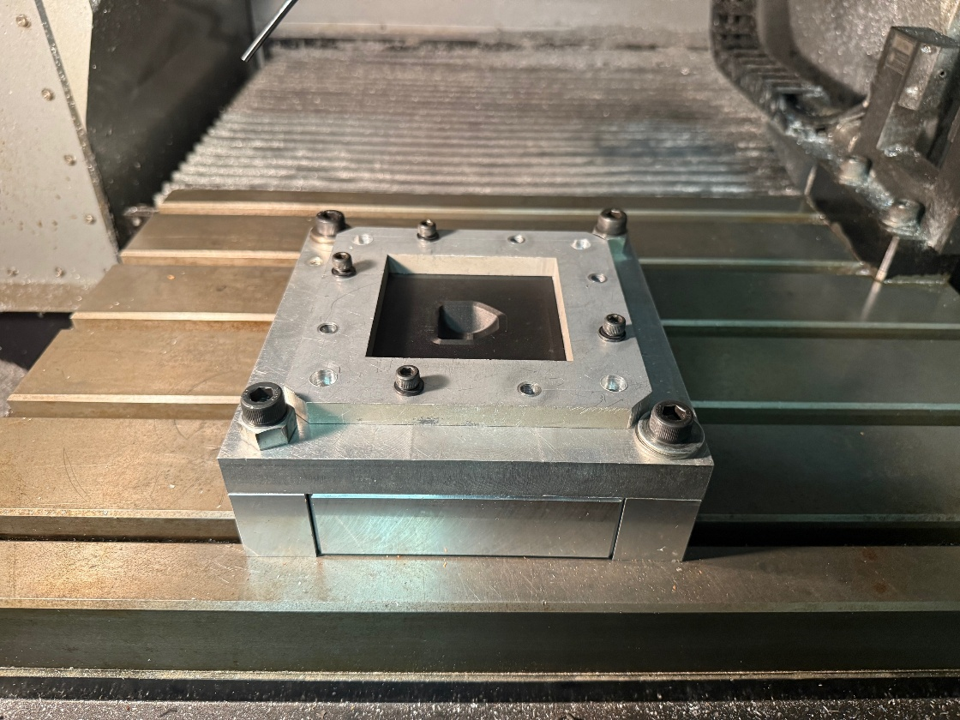
Figure 3.7: Jig arrangement [Author, 2025]

Figure 3.3: Incremental stretch forming oil bath configuration (Author, 2025 )

Chapter 4: Incremental Forming Experiment

4.1 Experimental Setup

Two different processes for with and without a mold
Process of conducting one incremental forming experiment with the mold:
Mold inside the jig-> secure the work piece to jig -> run the G-code -> wait for the program to complete -> move the tool to a safe height so that it does not become damaged when removing the test piece -> remove the test piece -> repreat.

Process of conducting one incremental forming experiment without the mold:
Increase the height of the jig (so that the machining center can reach the required depth) -> secure the work piece to jig -> run the G-code -> wait for the program to complete -> move the tool to a safe height so that it does not become damaged when removing the test piece -> remove the test piece -> repreat.

Analysis of the results using a 3D scanner to get accurate dimensions for the formed shape.

4.2 Procedure
Starting the machine:
- Press the button to the left of the power button (button has the word "source" written on it)
- Turn the mode to auto to ensure that I can use the NC code
- Wait for the machine to output a large green button in the center of the screen with power written on it
- Press the power button that is next to the controller
- For the 3 x 3 origin point order of finding the origin is from top to bottom right to left is the priority of origin setting
- Go to files from the menu bar at the bottom of the screen, they are grey boxes
- Select the middle gray button to select the "machine warm up (E25-sprun3M... )" NC code found in the files menu->HDD1 -> E25-sprun3M... (This process takes about an 45 min to an hour)
- Don't forget to press the execute button (実行) that is in the bottom right corner of the screen. (might need to navigate to find it)
- After sections 7 and 7a press the cycle start and wait 45 to an hour.
While the machine is warming up:
- Turn on the computer and select the profile that is in the middle
- The name is something like "pel2014" and the password is "pelpel"
- Double click the "GCode" shortcut on the desktop
- Drag the code from the USB to that folder
Setting the origin for the tool:
- After the warmup process must "zero" or find the origin with respect to the jig
- Ensure the "thicker tool" is attached, if not go through the next steps if it is already in then skip to 10c.
- To do so must switch the tool out by pressing the tool switch button (near the bottom left of all the buttons)
- the tool will just fall out so be ready to catch it
- Using the manual adjustment and having the tool spinning by pressing the sp cw button have the tool touch the outer part of the jig until the tool aligns
- Do this two times for both the X and Y directions to ensure that the zero is accurate, make sure after every time you touch you press the "zeroing button" that is on the screen.
- To do the "zeroing" for the Z direction, you must put the "green light" device on the material and then slowly lower the tool until the light turns on, raise the tool and do it two more times.
- Make sure to add 5 mm to the zeroing AFTER the zeroing to the main jig is done. This is to ensure room for error
- After this, you move to the center of your machine shape. (make sure to move the origin off by the amount that your tool will move on its initial movement for an offset. For example, if my first movement of the tool from the origin is to X 10 Y 10 Z 10, then you must offset your origin by X - 10 Y - 10 Z -10 so that the tool will actually make contact with the workpiece.)
- Go back to the machine and select the code and let it run after the warmup is finished
- Set the "Feed rate %" dial to 0 before executing in order to make sure that it does not move to fast on start up
- "Cycle start" to start the program

4.3 Results

Chapter 5: Conclusion and Future Improvements

Appendix
Table A1: Sample of the Toolpath Data for Truncated Cone.
Coordinate Number | x | y | z
1 | 35.38074 | 16.98353 | 0
2 | -24.3741 | 8.981753 | 20.16743
3 | 13.69313 | 7.26465 | 35.19882
4 | -27.8541 | -19.5488 | 8.404538
5 | -30.4515 | 4.178701 | 0
6 | 3.737267 | -18.347 | 30.56381
7 | 11.69576 | 37.38804 | 1.108847
8 | -15.4359 | -31.4054 | 7.022253
9 | 7.207543 | -25.1519 | 0
10 | -18.2936 | -18.5911 | 19.88553
11 | 10.62484 | -32.4655 | 8.289417
12 | 2.843407 | -15.5052 | 34.86311
13 | 6.157133 | -29.6092 | 13.94509
14 | 21.27377 | 2.94206 | 26.57677
15 | -4.37845 | 20.54852 | 27.25231
16 | 2.544194 | 16.76084 | 33.12099
17 | -16.3648 | -7.26247 | 0
18 | 2.508552 | 22.63757 | 0
19 | -21.9715 | 18.83982 | 0
20 | -25.9499 | 29.48961 | 1.013605
21 | 2.603134 | -13.6337 | 0
22 | 18.75938 | 29.88954 | 0
23 | -12.8895 | -0.04869 | 39.00607
24 | -25.3572 | -8.68166 | 0
25 | -3.58629 | 27.33321 | 0
26 | 24.916 | 2.324154 | 21.41337
27 | 3.57487 | -9.04673 | 43.53424
28 | -13.7942 | -1.55114 | 0
29 | -32.3798 | 21.53292 | 1.478903
30 | -7.74691 | -30.0426 | 12.74601
31 | -10.1278 | -25.489 | 0
32 | -8.70421 | -14.0673 | 0
33 | 15.25032 | -29.5634 | 0
34 | -7.70801 | -37.0219 | 3.022466
35 | 25.47657 | -5.81376 | 19.83967
36 | 30.69521 | 6.550145 | 12.28288
37 | 15.57037 | -6.714 | 0
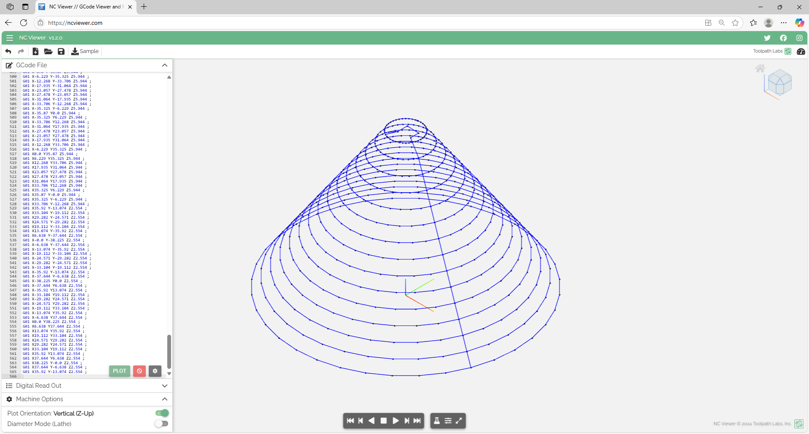
Figure A1: NC Viewer Screenshots of Toolpath Validation [Author, 2025].

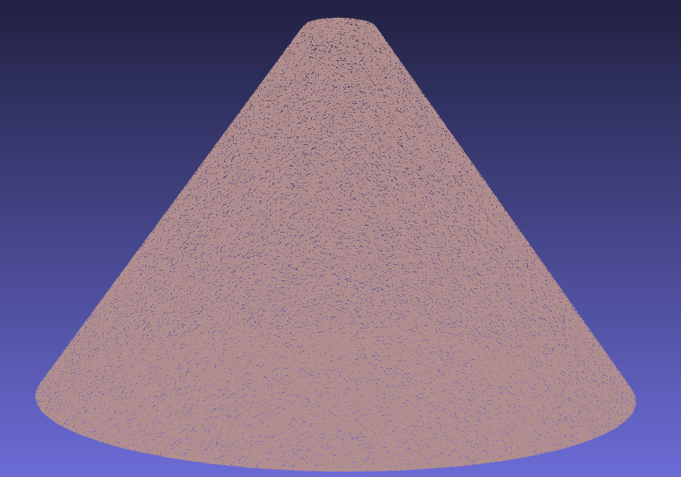
Figure A2: Point Cloud of the Truncated Cone [Author, 2025].

import pandas as pd
import numpy as np
from scipy.spatial import ConvexHull
from stl import mesh

# Configurable parameters
TOOL_DIAMETER = 3.4 # Tool diameter (mm)
Z_SPRINGBACK_OFFSET = -0.1
LAYER_THICKNESS = 1.0
MIN_DISTANCE = 0.5
Z_OFFSET = 50.5
SAFE_Z_RELATIVE = 50.0

# Load STL file and extract points
def load_stl_to_dataframe(stl_file, layer_thickness=1.0):
stl_mesh = mesh.Mesh.from_file(stl_file)
vertices = stl_mesh.vectors.reshape(-1, 3)
df = pd.DataFrame(vertices, columns=['x', 'y', 'z'])
df = df.drop_duplicates().reset_index(drop=True)
df['z'] = np.round(df['z'] / layer_thickness) * layer_thickness
return df.dropna()

# Filter close points to prevent clustering
def filter_close_points(points, min_distance=0.5):
filtered = [points[0]]
for p in points[1:]:
if np.linalg.norm(p - filtered[-1]) >= min_distance:
filtered.append(p)
return np.array(filtered)

# Sort points to prevent doubling back
def sort_points_no_overlap(points):
center = points.mean(axis=0)
angles = np.arctan2(points[:, 1] - center[1], points[:, 0] - center[0])
sorted_indices = np.argsort(angles)
sorted_points = points[sorted_indices]
n = len(sorted_points)
for i in range(n):
p1, p2 = sorted_points[i], sorted_points[(i + 1) % n]
for j in range(i + 2, n):
p3, p4 = sorted_points[j], sorted_points[(j + 1) % n]
if intersects(p1, p2, p3, p4):
sorted_points[i + 1:j + 1] = sorted_points[i + 1:j + 1][::-1]
return sorted_points

# Check if segments intersect
def intersects(p1, p2, p3, p4):
def ccw(A, B, C):
return (C[1] - A[1]) * (B[0] - A[0]) > (B[1] - A[1]) * (C[0] - A[0])
return ccw(p1, p3, p4) != ccw(p2, p3, p4) and ccw(p1, p2, p3) != ccw(p1, p2, p4)

# Smooth hull points
def smooth_hull_points(points, alpha=0.3):
smoothed = points.copy()
for i in range(len(points)):
prev = points[(i - 1) % len(points)]
next = points[(i + 1) % len(points)]
smoothed[i] = (1 - alpha) * points[i] + alpha * (prev + next) / 2
return smoothed

# Apply reverse offset using centroid-based method
def reverse_offset(points, TOOL_DIAMETER=2.5, z_springback_offset=-0.1):
adjusted_points = points.copy()
center = points[:, :2].mean(axis=0)
distances = np.linalg.norm(points[:, :2] - center, axis=1)
layer_radius = distances.max() if distances.size > 0 else 1.0
print(f"Layer at Z={points[0, 2]:.2f}, points={len(points)}, radius={layer_radius:.2f} mm, TOOL_DIAMETER={TOOL_DIAMETER:.2f} mm")
for i, point in enumerate(adjusted_points):
direction = point[:2] - center
norm = np.linalg.norm(direction)
if norm > 1e-6:
direction /= norm
offset = TOOL_DIAMETER * direction
adjusted_points[i, :2] -= offset
print(f"Point {i}: Offset applied = {offset[0]:.2f}, {offset[1]:.2f}")
adjusted_points[i, 2] += z_springback_offset
adjusted_points[:, :2] = smooth_hull_points(adjusted_points[:, :2])
x_min, x_max = adjusted_points[:, 0].min(), adjusted_points[:, 0].max()
y_min, y_max = adjusted_points[:, 1].min(), adjusted_points[:, 1].max()
adj_distances = np.linalg.norm(adjusted_points[:, :2] - center, axis=1)
adj_layer_radius = adj_distances.max() if adj_distances.size > 0 else 1.0
print(f"Adjusted radius={adj_layer_radius:.2f} mm")
print(f"Bounding box: X=[{x_min:.2f}, {x_max:.2f}], Y=[{y_min:.2f}, {y_max:.2f}]")
return adjusted_points

# Load reference toolpath from STL file
stl_file = 'test_piece_3.stl'
df = load_stl_to_dataframe(stl_file, layer_thickness=LAYER_THICKNESS)

# Main toolpath generation loop
ll = []
prev_exit_point = None
z_levels = sorted(df['z'].unique(), reverse=True)

# Calculate the desired uniform layer spacing
if len(z_levels) > 1:
z_diffs = [z_levels[i] - z_levels[i + 1] for i in range(len(z_levels) - 1)]
avg_spacing = np.mean(z_diffs)
print(f"Average layer spacing in input data: {avg_spacing:.3f} mm")
else:
avg_spacing = 1
print("Only one Z level in input data, using default spacing of 1 mm")

# Reassign Z levels to be uniformly spaced
uniform_z_levels = []
start_z = z_levels[0]
for i in range(len(z_levels)):
new_z = start_z - i * avg_spacing
uniform_z_levels.append(new_z)

# Calculate the center of the first layer for the initial move
center_x, center_y = None, None
for layer_idx, current_layer_z in enumerate(z_levels):
current_layer = df[df['z'] == current_layer_z][['x', 'y', 'z']].values
if len(current_layer) >= 5:
center_x, center_y = current_layer[:, :2].mean(axis=0)
break
if center_x is None or center_y is None:
print("Warning: Could not compute center from any layer. Using (0, 0) as fallback.")
center_x, center_y = 0.0, 0.0

# Process each layer with the new uniform Z levels
for layer_idx, current_layer_z in enumerate(z_levels):
current_layer = df[df['z'] == current_layer_z][['x', 'y', 'z']].values
if len(current_layer) < 5:
print(f"Skipping layer at Z={current_layer_z:.2f} due to insufficient points ({len(current_layer)})")
continue

layer_points_2d = current_layer[:, :2]
try:
hull = ConvexHull(layer_points_2d)
hull_coords = layer_points_2d[hull.vertices]
except Exception as e:
print(f"Skipping layer at Z={current_layer_z:.2f} due to hull error: {str(e)})")
continue

if hull_coords.shape[0] < 5:
print(f"Skipping layer at Z={current_layer_z:.6f} due to insufficient hull vertices ({hull_coords.shape[0]})")
continue

hull_coords = filter_close_points(hull_coords, min_distance=MIN_DISTANCE)

hull_z = np.full((hull_coords.shape[0], 1), uniform_z_levels[layer_idx])
hull_points_3d = np.hstack([hull_coords, hull_z])

adjusted_points_3d = reverse_offset(hull_points_3d, TOOL_DIAMETER=TOOL_DIAMETER, z_springback_offset=Z_SPRINGBACK_OFFSET)
adjusted_points_2d = adjusted_points_3d[:, :2]

sorted_points = sort_points_no_overlap(adjusted_points_2d)

# For the first layer, start at the point closest to the centroid
if layer_idx == 0:
centroid = np.array([center_x, center_y])
dists = np.linalg.norm(sorted_points - centroid, axis=1)
start_idx = np.argmin(dists)
sorted_points = np.roll(sorted_points, -start_idx, axis=0)
elif prev_exit_point is not None:
dists = np.linalg.norm(sorted_points - prev_exit_point[:2], axis=1)
start_idx = np.argmin(dists)
sorted_points = np.roll(sorted_points, -start_idx, axis=0)

sorted_layer = np.hstack([sorted_points, np.full((sorted_points.shape[0], 1), adjusted_points_3d[0, 2])])
layer_path = list(sorted_layer)
layer_path.append(layer_path[0]) # Close the loop
ll.extend(layer_path)
prev_exit_point = layer_path[0]

if len(ll) == 0:
print("Warning: No toolpath points generated. Check input data or layer filtering.")
exit()

# Apply Z offset to drop the toolpath
ll = np.array(ll)
ll[:, 2] -= Z_OFFSET # Subtract z_offset from all Z coordinates

# Round toolpath coordinates to 2 decimal places
ll = np.round(ll, 2)

# Save toolpath to CSV
pd.DataFrame(ll, columns=['x', 'y', 'z']).to_csv('toolpath.csv', index=False)

# Convert to G-code
df_ltp = pd.read_csv('toolpath.csv')

# Round coordinates to 2 decimal places and format explicitly
df_ltp['x'] = df_ltp['x'].round(2)
df_ltp['y'] = df_ltp['y'].round(2)
df_ltp['z'] = df_ltp['z'].round(2)

df_gchord = pd.DataFrame({
'G': 'G01',
'x': 'X' + df_ltp['x'].map('{:.2f}'.format),
'y': 'Y' + df_ltp['y'].map('{:.2f}'.format),
'z': 'Z' + df_ltp['z'].map('{:.2f}'.format),
'EOB': ';'
})

first_x = round(df_ltp.iloc[0]['x'], 2)
first_y = round(df_ltp.iloc[0]['y'], 2)
first_z = round(df_ltp.iloc[0]['z'], 2)

# Modified G-code header to start from the centroid
gcode_header = [
"G90 ; (Absolute positioning)",
"G21 ; (Set units to millimeters)",
"M03 ; (Start spindle)",
"S500 ; (Setting spindle speed)",
"F1000 ; (Set feedrate)",
f"G00 X{center_x:.2f} Y{center_y:.2f} ; (Rapid move to centroid)",
f"G01 Z{first_z:.2f} ; (Drop to first point's Z)",
f"G01 X{first_x:.2f} Y{first_y:.2f} ; (Move to first toolpath point)"
]

last_x = round(df_ltp.iloc[-1]['x'], 2)
last_y = round(df_ltp.iloc[-1]['y'], 2)

# Final safe Z is relative to the last point's Z position
last_z = df_ltp.iloc[-1]['z']
final_safe_z = last_z + SAFE_Z_RELATIVE

gcode_footer = [
f"G01 X{last_x:.2f} Y{last_y:.2f} Z{final_safe_z:.2f} ; (Retract tool to safe Z)",
"M30 ; (End of program)"
]

with open('Gchord.txt', 'w') as f:
for line in gcode_header:
f.write(line + '\n')
df_gchord.to_csv(f, index=False, sep=" ", header=False, mode='a')
for line in gcode_footer:
f.write(line + '\n')
Code A1: Complete Python CAM System Code [Author, 2025].
%pip install pandas
%pip install scipy
%pip install numpy-stl
Code A2: Libraries required to download
import pyvista as pv
import csv
import pandas as pd
import numpy as np

# Load STL file
mesh = pv.read('test_piece_3.stl')
points = mesh.points

# Export point cloud to CSV
with open('dots.csv', 'w') as f:
writer = csv.writer(f)
writer.writerows(points)

# Process point cloud
df = pd.read_csv('dots.csv')
df = df.dropna()
df = df.set_axis(['x', 'y', 'z'], axis='columns')
maxi = df['z'].max()
mini = df['z'].min()
df = df[df['z'] > mini + 0.01]
df.to_csv('dots.csv')
df = pd.read_csv('dots.csv')
ll = np.array([0, 0, 0])
pp = np.array([0, 0, 200])

# Toolpath generation loop
while len(df) > 0:
s = df['z'].max()
df_z = df[df['z'] == s]
df_z.to_csv('layer.csv')
df_z = pd.read_csv('layer.csv')
df_z = df_z.drop(df_z.columns[[0, 1]], axis=1)
df_z.to_csv('layer.csv')
l = np.loadtxt('layer.csv', delimiter=',', dtype='float64', skiprows=1, usecols=[1, 2, 3])
n = len(df_z)
c = 0
ltp = np.array([0, 0, 0])
if n > 1:
while n > 0:
ld = [np.linalg.norm(pp - l[j]) for j in range(n)]
k = ld.index(min(ld))
lk = l[k]
ltp = np.vstack([ltp, lk])
if c == 0:
llk = lk
l = np.delete(l, k, 0)
n -= 1
pp = lk
c += 1
ltp = np.delete(ltp, 0, 0)
ll = np.vstack([ll, ltp])
df = df[df['z'] < s]
ll = np.round(ll, 3)
with open('toolpath.csv', 'w') as f:
writer = csv.writer(f)
writer.writerows(ll)

# G-code conversion
df_ltp = pd.read_csv('toolpath.csv')
df_ltp = df_ltp.set_axis(['x', 'y', 'z'], axis='columns')
l = np.loadtxt('toolpath.csv', delimiter=',', dtype='float64', skiprows=1, usecols=[1, 2, 3])
lx, ly, lz = l[:, 0], l[:, 1], l[:, 2]
lx = ['X' + str(x) for x in lx]
ly = ['Y' + str(y) for y in ly]
lz = ['Z' + str(z) for z in lz]
df_gchord = pd.DataFrame({'G': 'G01', 'x': lx, 'y': ly, 'z': lz, 'EOB': ';'})
df_gchord.to_csv('Gchord.txt', index=False, sep=" ")
Code A3: Previous research’s CAM system

Chapter 6: References
- Bagherifard, S., Ghelichi, R., & Guagliano, M. (2018). Shot peening: A review of the process and its applications. Journal of Materials Processing Technology, 258, 188–202.
- Duflou, J. R., Habraken, A. M., Cao, J., Malhotra, R., Bambach, M., Adams, D., ... & Merklein, M. (2018). Single point incremental forming: An assessment of the progress and technology trends from 2005 to 2015. Journal of Manufacturing Processes, 28(3), 373–391. https://doi.org/10.1016/j.jmapro.2017.04.015
- Guttag, J. V. (2021). Introduction to computation and programming using Python (3rd ed.). The MIT Press.
- Ikari, T., & Tanaka, H. (2023). Feasibility study of laser-assisted incremental forming for carbon fiber reinforced thermoplastic based on 3D CAD data. Sophia University Technical Report.
- Ikari, T., & Tanaka, H. (2023). Feasibility study of single point incremental forming for discontinuous fiber CFRP using oil bath heating. Sophia University Technical Report.
- Mitsumori, T. (2023). Development of incremental forming techniques for automotive CFRP components. Sophia University Technical Report.
- Sharma, V., Sharma, V., & Shukla, O. J. (2014). Principles and practices of CAD/CAM. Katson Books.
- Shovic, J. C., & Simpson, A. (2021). Python all-in-one for dummies. Wiley.
- Smid, P. (2006). CNC programming techniques. Industrial Press.
- Daleffe, A., Schaeffer, L., Fritzen, D., & Castelan, J. (2013). Analysis of the incremental forming of titanium F67 grade 2 sheet. Key Engineering Materials, 554–557, 195–203. https://doi.org/10.4028/www.scientific.net/KEM.554-557.195
- Nissan Motor Corporation. (2022). Lightweight materials in electric vehicle manufacturing. Nissan Technical Review.
- Tanata, H. (2023). Carbon-fiber-reinforced-polymer manufacturing techniques. Sophia University Technical Report.
- Ford Motor Company. (2021). Advanced manufacturing techniques for electric vehicle components. Ford Technical Bulletin.
- Nissan Motor Corporation. (2023). Innovations in lightweight structural components for the Nissan Leaf. Nissan Engineering Report.
- Airbus S.A.S. (2022). Composite materials in modern aircraft design: The A350 XWB. Airbus Technical White Paper.
- Boeing Company. (2021). CFRP applications in the 787 Dreamliner. Boeing Engineering Journal.
- International Civil Aviation Organization (ICAO). (2020). Aviation and climate change: Strategies for emissions reduction. ICAO Environmental Report.
- Smith, J. R., & Lee, K. H. (2022). Incremental forming for patient-specific prosthetic sockets using CFRTP. Journal of Medical Engineering & Technology, 46(5), 412–420. https://doi.org/10.1080/03091902.2022.2054332
- Chen, L., & Zhang, W. (2023). Radiolucent CFRTP components for medical imaging applications. Medical Materials and Manufacturing, 15(3), 89–97.
- Vestas Wind Systems A/S. (2023). Lightweight composites for wind turbine blade optimization. Vestas Technical Review.
- Apple Inc. (2022). Advances in CFRTP for consumer electronics enclosures. Apple Materials Science Report.
- ([PMC: State of the Art in Incremental Forming](https://pmc.ncbi.nlm.nih.gov/articles/PMC11642863/)).
- [ScienceDirect: Incremental Forming](https://www.sciencedirect.com/topics/engineering/incremental-forming).
- [ScienceDirect: Incremental Forming](https://www.sciencedirect.com/topics/engineering/incremental-forming).
- The technology of Incremental Sheet Forming—A brief review of the history - ScienceDirect
- Bachmann, Jens & Hidalgo, Carme & Bricout, Stéphanie. (2017). Environmental analysis of innovative sustainable composites with potential use in aviation sector—A life cycle assessment review. Science China Technological Sciences. 60. 10.1007/s11431-016-9094-y.

